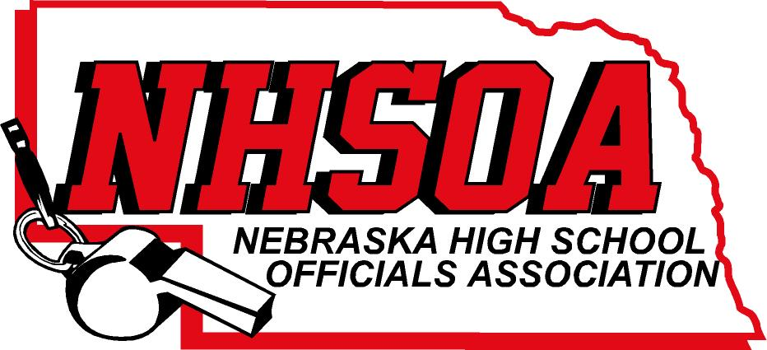

Board of Directors Meeting
NSAA Office 500 Charleston Street
9:00AM April 7th
- Call meeting to order
- Meet with NSAA Board of Directors
- Treasurer Report (Sue email out)
- Approval of December 20th minutes (Doug please email)
- Nick Inzerello with Hudl Report
- Supervisor of Officials Report
- NHSOA Director Report
- Sport Chairperson Report
- Other Business (Hudl Administrator—Website)
- Adjournment

