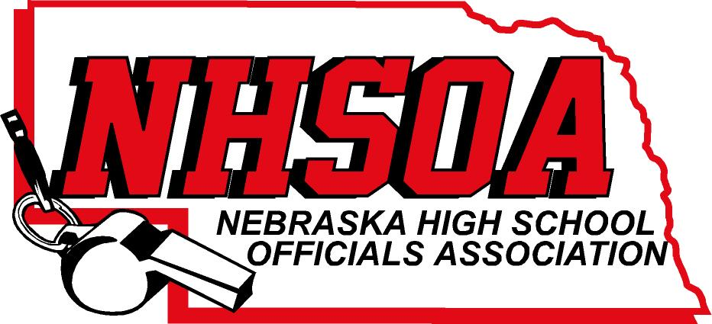

Board of Directors Meeting
NSAA Office 500 Charleston Street
11:00 AM December 20th^{th} 2021
- Call meeting to order
- Treasurer Report (Sue email out)
- Approval of August 30th minutes (Doug please email)
- Supervisor of Officials Report
- NHSOA Director Report
- Sport Chairperson Report
- Other Business
- Adjournment

