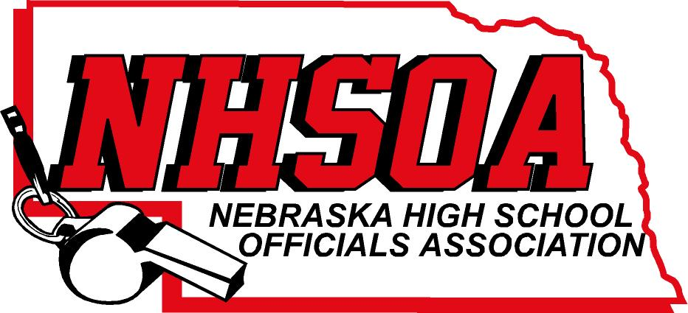

Board of Directors Meeting
NSAA OFFICE 500 Charleston Street
Wednesday April 26th 11:00 am
- Call meeting to order/recognition of guests
- Treasurer Report (Sue)
- Approval of December 14th meeting minutes (Doug please email)
- Wyat Morse (NDE Health & PE Specialist)
- Sport Chairperson Reports
- Supervisor of Officials Report (Nate)
- NHSOA Director Report
A. Scholarship Winner
B. NHSOA Money to CD or Money Market
C. Golf Outing Update
VIII. Other Business (Meeting Dates)
IX Adjournment

