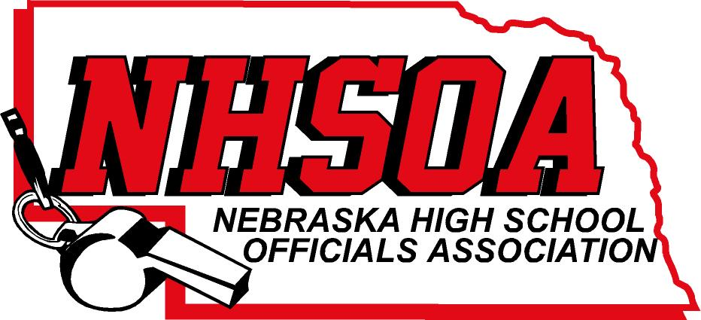

Board of Directors Meeting
ZOOM MEETING
Wednesday April 3rd 11:00 am
- Call meeting to order/recognition of guests
- Treasurer Report (Sue)
- Approval of December 13th and January 24th meeting minutes (Doug please email)
- Sport Chairperson Reports
- NHSOA Director Report
- Supervisor of Officials Report (Nate)
- Action/Discussion Items
A. 10,20,30, year officials recognition (Todd information)
B. NHSOA Audit, financials, etc.
C. Bill Lewis Scholarship
VIII. Other Business (Meeting Dates)
IX Adjournment

