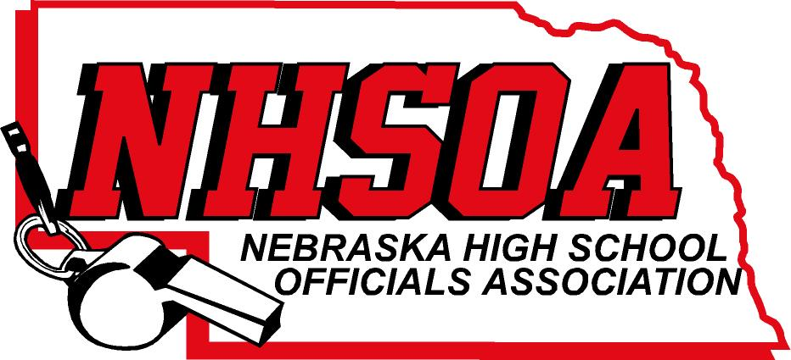

Board of Directors Meeting
ZOOM MEETING
Wednesday August 31st, 10:00 am
- Call meeting to order
- Treasurer Report (Sue)
- Approval of June 8th meeting (Doug please email)
- Sport Chairperson Reports
- Supervisor of Officials Report (Nate)
VI Action Items
A. Tabled from 7/8/22. Hudl Administrator Payment for 2022-2023 $1500 (Brian ONeal)
B. Tabled from 7/8/22 2022-2023 Budget
C. Increase mileage rate for board members to match NSAA
VII. NHSOA Director Report
VIII. Other Business (meeting dates) December 7th, April 5th
IV. Adjournment

