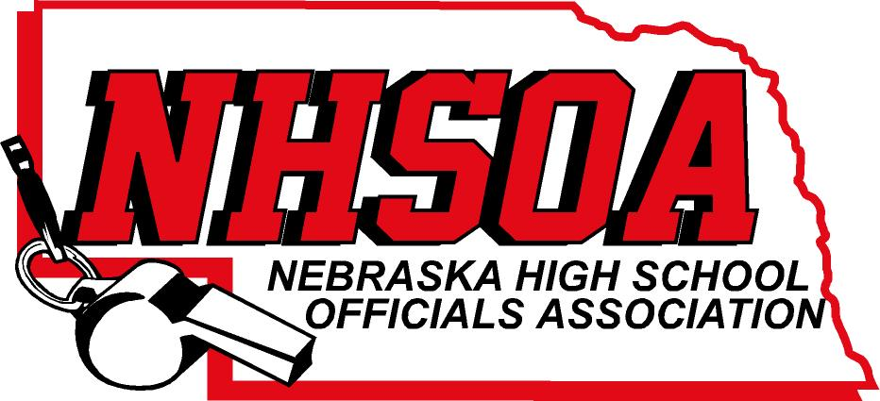

Board of Directors Meeting
NSAA OFFICE 500 Charleston Street
Wednesday December 13th 11:00 am
- Call meeting to order/recognition of guests
- Treasurer Report (Sue)
- Approval of August 2nd meeting minutes (Doug please email)
- Sport Chairperson Reports
- NHSOA Director Report
- Supervisor of Officials Report (Nate)
- Action/Discussion Items
A. Website Administrator Fee
B. Summit Room Fees
C. Bill Lewis Scholarship Winner Selection Committee
VIII. Other Business (Meeting Dates)
IX Adjournment

