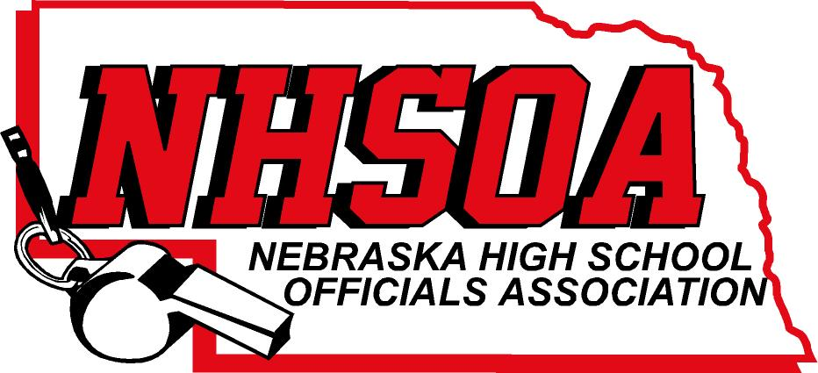

Board of Directors Meeting
NSAA OFFICE 500 Charleston Street/ for those that can’t attend ZOOM MEETING
Wednesday December 7th, 11:00 am
- Call meeting to order/recognition of guests
- Treasurer Report (Sue)
- Ken Mar Fundraising Idea for Scholarships
- Approval of August 31st meeting (Doug please email)
- Sport Chairperson Reports
- Supervisor of Officials Report (Nate)
VI Action Items
A. Tabled from 8/31/22. Hudl Administrator Payment for 2022-2023 $1500 (Brian ONeal)
B. Tabled from 8/31/22 2022-2023 Budget
C. Increase mileage rate for board members to match NSAA
VII. NHSOA Director Report
VIII. Other Business (meeting dates) April 5th
IV. Adjournment

