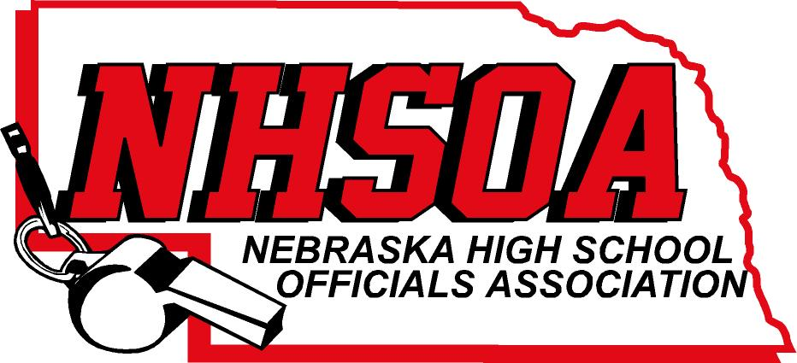

Board of Directors Meeting
NSAA Office 500 Charleston Street
Wednesday August 2nd, 11:00 am
- Call meeting to order
- Treasurer Report (Sue)
- Approval of June 7^{th meeting} (Doug please email)
- NHSOA Director Report
- Sport Chairperson Report
- Supervisor of Officials Report (Nate)
VII Action/Discussion Items
A. Hiring company to keep web site up to date
B. Money Market for NHSOA Account
VIII. Other Business (meeting dates)
IX. Adjournment

