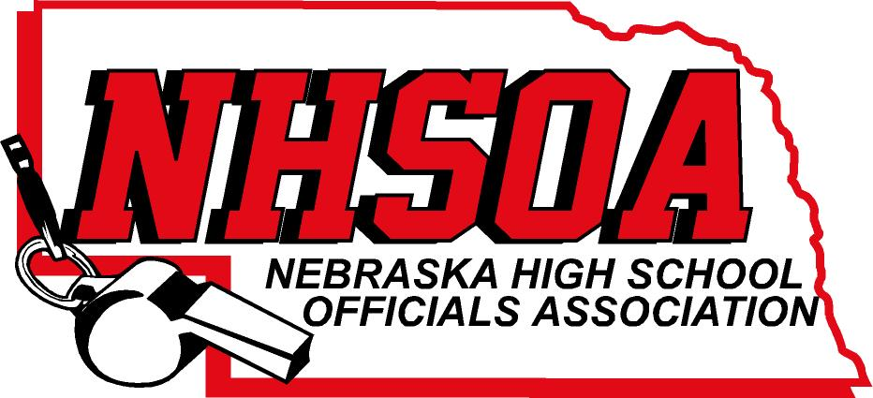

Board of Directors Meeting
NSAA Office 500 Charleston Street
Wednesday June 7th, 11:00 am
- Call meeting to order
- Treasurer Report (Sue)
- Approval of April 26th meeting (Doug please email)
- Discuss Hudl Contract (only purchasing sports that utilize)
- Supervisor of Officials Report (Nate)
VI Action Items
A. Treasurer and Secretary for 2022-2023 fiscal year
B. Hudl Administrator Payment for 2023-2024 (Dennis Podjenski)
C. 2023-2024 Budget
VII. Other Business (meeting dates)
VIII. Adjournment

